**image recognition with IBM cloud visual recognition project**

**About Dataset**

**1.IBM Cloud Visual Recognition:**

Utilize IBM Cloud Visual Recognition service to build and deploy your solution.

**2. Data Collection:**

Gather a diverse dataset of document images representing various types and formats.

**3. Labeling:**

Annotate the dataset with ground truth labels, describing document content and structure.

**4. Data Split:**

Divide the dataset into training, validation, and testing subsets.

**5. Data Augmentation** :

Enhance dataset diversity with image transformations.

**6. Data Preprocessing:**

Prepare and normalize images for model compatibility.

**7. Balancing and Cleaning:**

Ensure balanced classes and remove duplicates or low-quality samples.

**8. Privacy and Security:**

Handle sensitive content responsibly, anonymizing or redacting as needed.

**9. Dataset Size**:

Larger datasets generally yield better model performance.

**10. Regular Updates:**

Plan for ongoing dataset updates to accommodate new document types.

**11. Licensing:**

Verify rights and permissions for dataset usage.

**Properties**

**Custom Models:**

You can train custom machine learning models specific to your image recognition needs.

**Pre-trained Models:**

IBM Cloud Visual Recognition offers pre-trained models for general image recognition tasks.

**Classifiers and Classes:**

Classifiers are sets of categories or classes that images can be classified into, allowing you to organize and categorize images.

**Classifying Images:**

You can use the service to classify and identify objects, scenes, and other elements within images.

**Detect Faces:**

The service can detect faces within images and provide information about facial features.

**Training and Model Evaluation:**

Ability to train and evaluate models based on your specific dataset to improve recognition accuracy.

**Integration and APIs:**

Provides APIs for seamless integration into your applications and systems, allowing for programmatic access to the service's capabilities.

**Preprocessing**

**Collection Image:**

Gathering a diverse set of images relevant to the intended classification task.

**Data Cleaning and Augmentation:**

Ensuring data quality by removing duplicates, correcting labels, and augmenting the dataset to increase its diversity and improve the model's robustness.

**Data Formatting:**

Organizing the images into a suitable format that can be used for training the model. This often involves converting images into a standardized format like JPEG or PNG.

**Data Labeling:**

Annotating images with relevant labels or tags that indicate the objects, scenes, or concepts depicted in the image. This labeled data serves as ground truth for training the model.

**Feature Extraction:**

Extracting meaningful features from the images, such as shapes, colors, textures, or other visual attributes. These features help the model understand and differentiate between different objects or patterns in the images.

**Normalization and Scaling:**

Adjusting the image data to have consistent scales, color ranges, or brightness levels, which helps in ensuring uniformity and aiding the training process.

**Dimensionality Reduction:**

Reducing the number of features while retaining relevant information, often through techniques like Principal Component Analysis (PCA), to simplify the model and improve computational efficiency.

|  |  |
| --- | --- |
|  |  |

**Block Diagram**

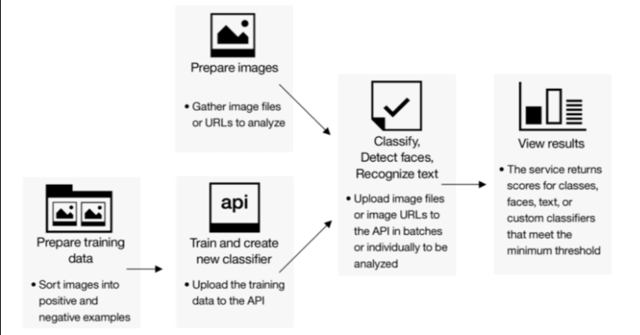

**Features extracation**

|  |  |  |  |
| --- | --- | --- | --- |
|  |  |  |  |
|  | | |

IBM Cloud Visual Recognition is a service that allows users to analyze and categorize images and videos using deep learning algorithms. One of its key features is feature extraction, which involves identifying distinct attributes or patterns in the visual data, allowing for a more nuanced understanding of the content.

Feature extraction in IBM Cloud Visual Recognition involves breaking down an image into various meaningful components, such as shapes, colors, textures, and patterns. These components, known as features, are then used to create a representation of the image that can be used for further analysis or classification.

By extracting features from images, the system can identify objects, recognize scenes, detect faces, and even determine specific characteristics of the visual content. These extracted features are essential for training machine learning models and enabling applications like object recognition, content moderation, and automated tagging.

Users can customize and fine-tune the feature extraction process based on their specific use cases and requirements, enhancing the accuracy and relevance of the analysis performed by the IBM Cloud Visual Recognition service.

**Conclusion**

IBM Cloud Visual Recognition is a service that allows developers to incorporate image recognition capabilities into their applications. The project's conclusion would typically involve assessing the effectiveness and performance of the image recognition model, evaluating its accuracy, precision, and recall in identifying various objects or features within images. Additionally, it would involve analyzing user feedback, fine-tuning the model based on insights gained during the project, and considering future enhancements or expansions of the application's functionality. The goal is to ensure that the image recognition system meets the desired objectives and delivers a reliable and efficient user experience.